1. Reservation Management

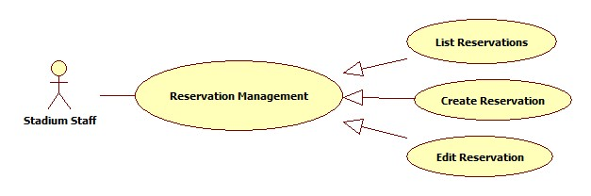

* 1. List Reservations

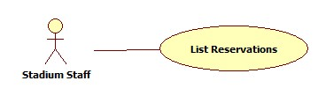

|  |  |  |  |  |
| --- | --- | --- | --- | --- |
| **USE CASE-n SPECIFICATION** | | | | |
| **Use-case No.** | <UC001> | **Use-case Version** | | <1.0> |
| **Use-case Name** | List Reservations | | | |
| **Author** | ThinhND | | | |
| **Date** | 12/02/2014 | **Priority** | High | |
| **Actor:**  Stadium Owner  **Summary:**  This use case describes listing reservations of stadium.  **Goal:**  List all reservations of stadium.  **Triggers:**  N/A  **Preconditions:**  Login as Stadium Owner role  **Post-conditions:**  N/A  **Main Success Scenario:**   |  |  |  | | --- | --- | --- | | Step | Actor Action | System Response | | 1 |  | The system shows list of fields. |   **Alternative Scenario:**   |  |  | | --- | --- | | Actor Action | System Response | |  |  |   **Exceptions:**  N/A  **Relationships:**  N/A  **Business Rules:**  N/A | | | | |

* 1. Create Reservation

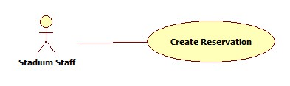

* 1. Edit Reservation

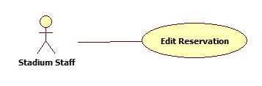

1. Stadium promotion management

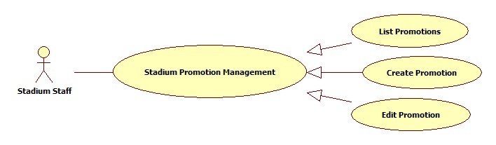

* 1. List Promotions

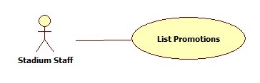

|  |  |  |  |  |
| --- | --- | --- | --- | --- |
| **USE CASE-n SPECIFICATION** | | | | |
| **Use-case No.** | <UC001> | **Use-case Version** | | <1.0> |
| **Use-case Name** | Stadium Promotion Management | | | |
| **Author** | ThinhND | | | |
| **Date** | 12/02/2014 | **Priority** | High | |
| **Actor:**  Stadium Staff  **Summary:**  This use case describe how to Manager such as View, Create, Update, and Delete all promotion of stadium.  **Goal:**  Manager all promotion of stadium  **Triggers:**  Actor click on View, Create, Update, Delete button to do with all promotion of stadium  **Preconditions:**  N/A  **Post-conditions:**    **Main Success Scenario:**   |  |  |  | | --- | --- | --- | | Step | Actor Action | System Response | | 1 | Click on Create to create a promotion | The system will respond to Create promotion page | | 2 | Enter information into text fields. Click on Save button to finish | The system will create new promotion in database. | | 3 | Click on promotion to view | The system will show the promotion with the information | | 4 | Click on Edit button to change promotion information | The system will show the promotion with page of information was filled |   **Alternative Scenario:**     |  |  | | --- | --- | | Actor Action | System Response | | Click on Cancel button to cancel | The system will back to previous page |   **Exceptions:**  N/A  **Relationships:**  N/A  **Business Rules:**  N/A | | | | |

* 1. Create Promotion

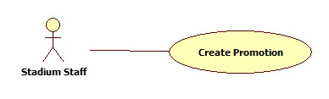

* 1. Edit Promotion

